HYBRID PUBLIC AUCTION
LARGE STONE/SIDING CAPE-COD HOUSE * 6-BR’s * COVERED REAR PORCH
.67-ACRE LEVEL LOT * 2-CAR ATTACHED GARAGE * HOUSE NEEDS REPAIR
THURSDAY SEPT 4, 2025 @ 6:00 PM
LOCATED AT: 155 South 3rd St. Akron, PA 17501 * Akron Boro
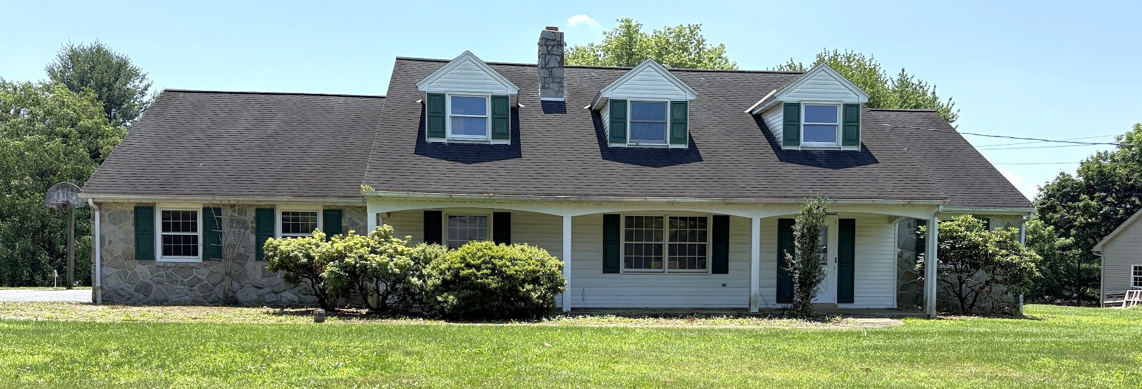
REAL ESTATE DETAILS: A large Cape-Cod style house w/ 2-car attached garage on a level .67-acre lot. This high-quality house was custom built in 1965, has approx. 2,743 sq. ft. plus 600+ sq. ft. in the basement. Main level includes 21’x 16’ kitchen/dining area w/ cherry cabinetry, dishwasher, stove, microwave, sink window overlooking back yard, patio doors to large covered rear porch; 16’x 14.5’ front living room w/ double-hung window & wood burning fireplace; 14.5’x 11.5’ recreation room w/ hardwood flooring & built-in cabinetry; 20’x 7.5’ office w/ private outside entrance; full bathroom w/ tub shower; powder bathroom; 14’x 9’ laundry room w/ abundant cabinetry; 20.7’x 21’ attached 2-car garage; 12’x 12’ BR #1 w/ closet; 12’x 10.5’ BR #2 w/ closet; front door foyer. Second level has 18.5’x 14’ BR #3 w/ closet; 13.5’x 13’ BR #4 w/ closet; 17’x 10’ BR #5 w/ closet; 13’x 13’ BR #6 or recreation room; full bathroom; 12’x 11’ Cedar-lined walk-in closet. Basement has 30’x 21’ visitors room w/ brick fireplace; 2nd outside concrete steps; cold cellar; 30’x 16’ utility room.
AUCTIONEER NOTE: Seems to be a quality custom build house, however a few repairs and updates are needed, bring your dreams and creativity. Oil furnace, central A/C; private well; public sewer; Akron Boro; Ephrata Area School District; taxes approx. $5,942. Auction is being held to settle an estate, come with your best offer.
OPEN HOUSE DATES: Saturdays Aug. 23 & 30, from 1-3 PM. Call/Text Auctioneer 717-587-8906
BRIEF TERMS: $35,000 down payment, balance in 60-days or before. This auction is held under the terms prepared by Attorney Glick, Goodley, Deibler & Fanning 717-354-7700. Buyer needs to verify any/all information. By placing a bid, buyer is acknowledging they accept the sellers’ terms & conditions.
Please visit our website www.martinandrutt.com or Facebook or Instagram
AUCTION FOR: HANS’ PETER NEUFELD ESTATE * AUCTION BY: MARTIN & RUTT AUCTIONEERS, LLC AY-2189-L
JOHN J. RUTT II, 717-587-8906 * MICHAEL J. MARTIN, 717-371-3333 * CAMERON J. RUTT, 717-875-6032

